Project 4:

Design

Simplified Sckhaedgeuler (SS)

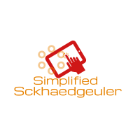

Snow College

*Generation of the Design Concepts and Ideas for the System*

Leedan Johnson, Alex Thayn, Jackson Porter

Table of Contents

**System Concept Statement** **3**

**Our Tailoring of This Project** **4**

**Our Personas** **5**

**Ideation & Sketching** **6**

Ideation 6

Sketching 7

**Our Workspace** **7**

**Our Team at work** **8**

**Sketches** **10**

**Physical Mockups** **12**

**Mental Models and Conceptual Design** **13**

Mental Model 13

Conceptual Design 16

Metaphors Used in Conceptual Design 17

Conceptual Sketches 18

**Storyboards** **21**

Building Manager 21

Student 22

Faculty 23

System Admin 24

**Wireframes** **25**

**Our Design Process** **26**

Techniques used 26

Lessons Learned 27

Insights gained 28

**Appendix** **30**

Reading 30

Resources 30

# System Concept Statement

The *Simplified Sckhaedgeuler* provides an all-around solution to room scheduling for the Snow College campus. From students to building managers our software adapts to fit each user’s needs:

* Experience a consistent and easy to use web interface.
* Finding a room for last minute study sessions is no longer a problem.
* Searching for the “right” room has been simplified, users can filter search results to find the room of their dreams.
* Academics take priority! No more getting kicked out of your reservation.
* Managers will maintain control of each building and receive up-to-date feedback about room issues from users.
* View and report issues with a room instantly.
* Never forget a meeting again! Sign up for notifications to receive reminders about your upcoming reservations and events to which you’ve been invited.

Our software helps all overcome the challenges of traditional room management, allowing the process to be effortless and enjoyable.

# Our Tailoring of This Project

One obvious way we tailored the activity is in the omission of a physical model. Since our product is software only, we cannot accurately depict it with a physical model. The tailoring of our project can also be seen by our inclusion of three personas. Our product will be used extensively by three very distinct groups, and we could not find a single persona that accurately represented all of these diverse perspectives. We chose to include three personas, one representing each of these distinct user roles. Likewise, we had to create storyboards depicting events that might befall each of our personas, or people like them.

We began our project with the ideation phase. We met together as a group and did some brainstorming, keeping our personas in mind as we did this activity. We also did some sketching as a group and many sketches individually that we presented to the group for review. Through ideation and sketching our design began to emerge. We created a mental model diagram to help us gain a better understanding of the user's mental model and how well our mental fit the user's perspective. Then we began to develop a conceptual model through sketching to map the mental model to a conceptual representation.

Overall, as we would be users of this system and know that atmosphere of the institution and what it would take and what other users want, we were able to incorporate design features that would please all different types of users and needs.

# Our Personas

In order to meet the needs of our users, we began by creating real personas for whom we could target our design. As the book suggested, we started off with several ‘candidate’ personas, and tried to narrow them down to one that would represent our users. We narrowed it down to three personas: Paul Jordan, Jonathan Steel, and Mary Smith. We were unable to eliminate any of these three, as they were so different, and each represented a distinct group who would be interacting with our product. Paul, Mary, and John were all three present in our minds as we engineered the user experience of the Simplified Sckhaedgeuler.

* Paul is a typical college student. He is a music major, working part time at a pizza place, and is involved with several group projects in multiple classes.
* Mary is the Library administrator at Snow College. As such, she is in charge of the rooms in the library. This includes handling reservations and managing equipment.
* John is employed by Snow College as the reservation System Administrator. John’s responsibilities include managing the reservation system in general, overseeing managers, and mediating problems.

# Ideation & Sketching

## Ideation

For ideation our team met in the the Computer Science classroom and collaboratively brainstormed ideas for our project. We focused on the 13 main points we had extrapolated from the Work Activity Affinity Diagram (our ideation bin from Project #3), and began by individually writing and sketching our ideas for the personas on the board under those 13 sections. After brainstorming individually, we came back together and began to explain our ideas to the other groups members.

During our ideation review we had the design-informing models in the back of our mind to make sure we covered all the needs that users had already expressed. We also thought about the barriers related to the user we discovered in our design informing models, and did our best to resolve, minimize or avoid them. We asked questions about ideas and added on to existing ideas and even came up with a few new ones as a group. One of the hardest things we had to be careful to not do is to not critique each other’s ideas and would remind ourselves to stop if a question turned into a critique.

Even in our ideation phase, we found that many of our ideas were better expressed with sketches. These simple sketches were all included in our final sketches in one form or another, and they served as a starting point for our more inclusive sketches.General ideas, interactions, flows and descriptions fit into diagrams and flows for our group.

## Sketching

The transition from ideation to sketching was a fluid one. We were able to express the design ideas that came up during ideation through sketches. Sketching served as the primary foundation for our conceptual models and helped us build an understanding of each of our different mental models as designers. Sketching also brought out many new ideas and possible solutions to user pain points.

# Our Workspace

We had two main “workspaces” one being our classroom and the other being virtual (through online collaboration). For the classroom we met at times we could have the room mostly to ourselves, free from distractions. The large whiteboards became our design canvas and we quickly filled up the whiteboards with our ideas. We also used paper and pencil in order to communicate ideas and shared them through online file sharing. This workspace became a place where we could bounce ideas around and do collaborative brainstorming without the concern we would be criticized. This workspace encouraged the flow of ideas and each team member brought a different perspective to the table which encouraged a variety of ideas.

Our virtual workspace became a place we could communicate our ideas while away from each other. As busy students we couldn’t always afford the time required to meet in person but with Google Drive and other various document sharing software we could maintain conversations and ask each other questions or review design ideas that came up between our physical meetings. This workspace allowed our project to continually move forward.

# Our Team at work

We met many times as a team during this phase of the project. We met in person and virtually to make sure we had time to communicate our ideas and work on our design together.

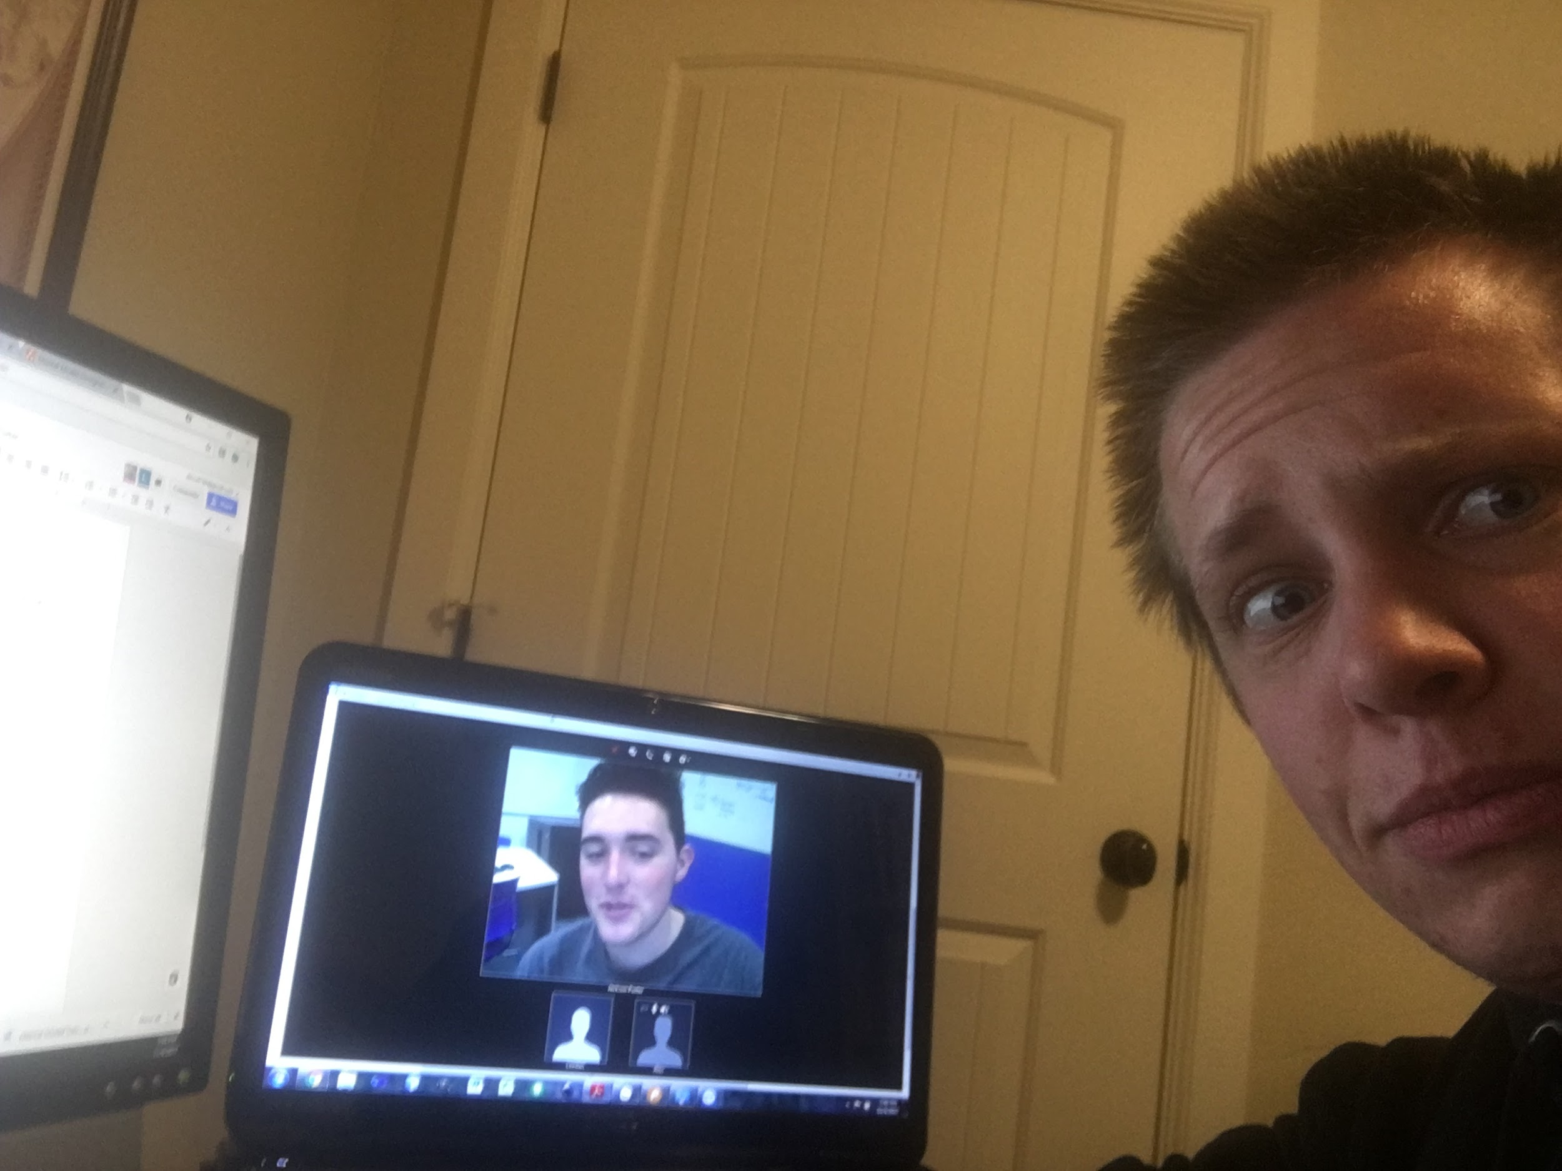

Alex using TeamViewer to meet virtually and collaborate with Jackson and Leedan

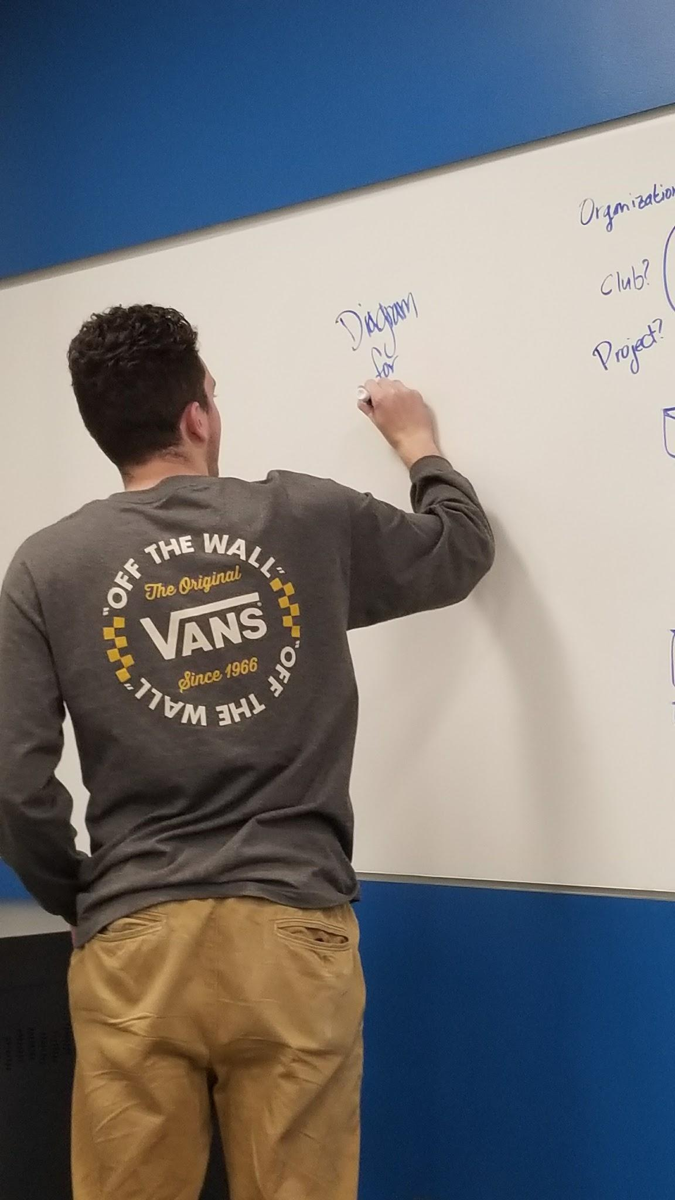

Jackson sketching away on the whiteboard

Leedan working on the project using virtual tools and collaborative means (GSuite)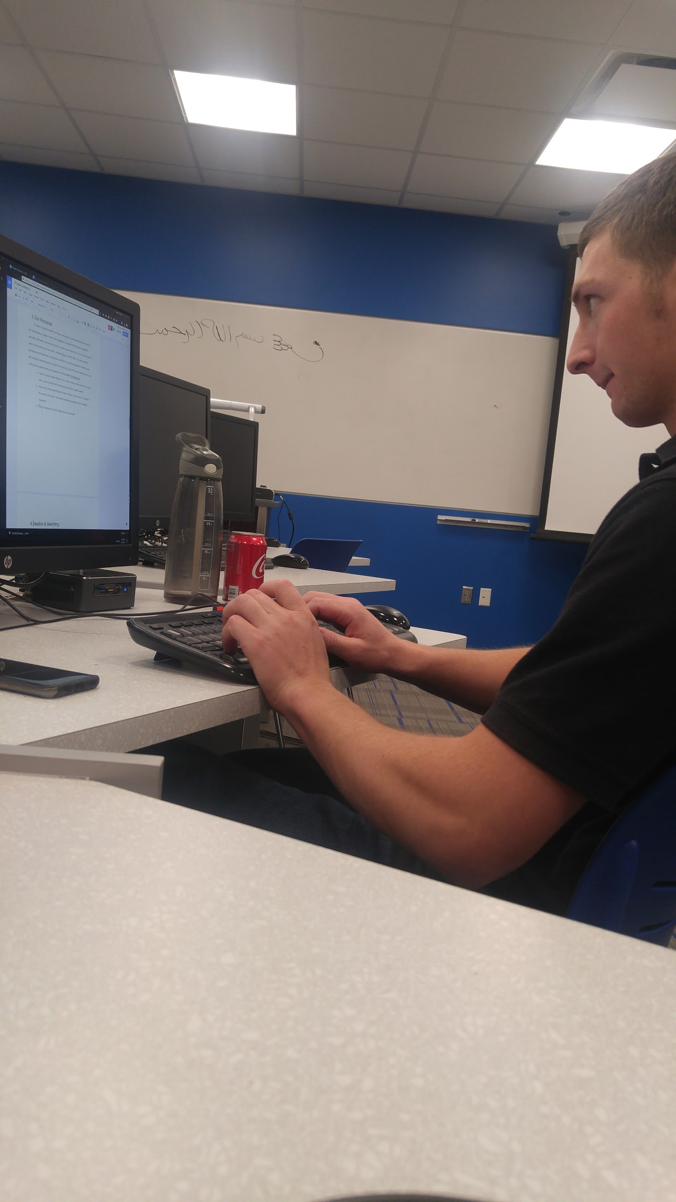

# Sketches

Here we included a few of the sketches from our project:

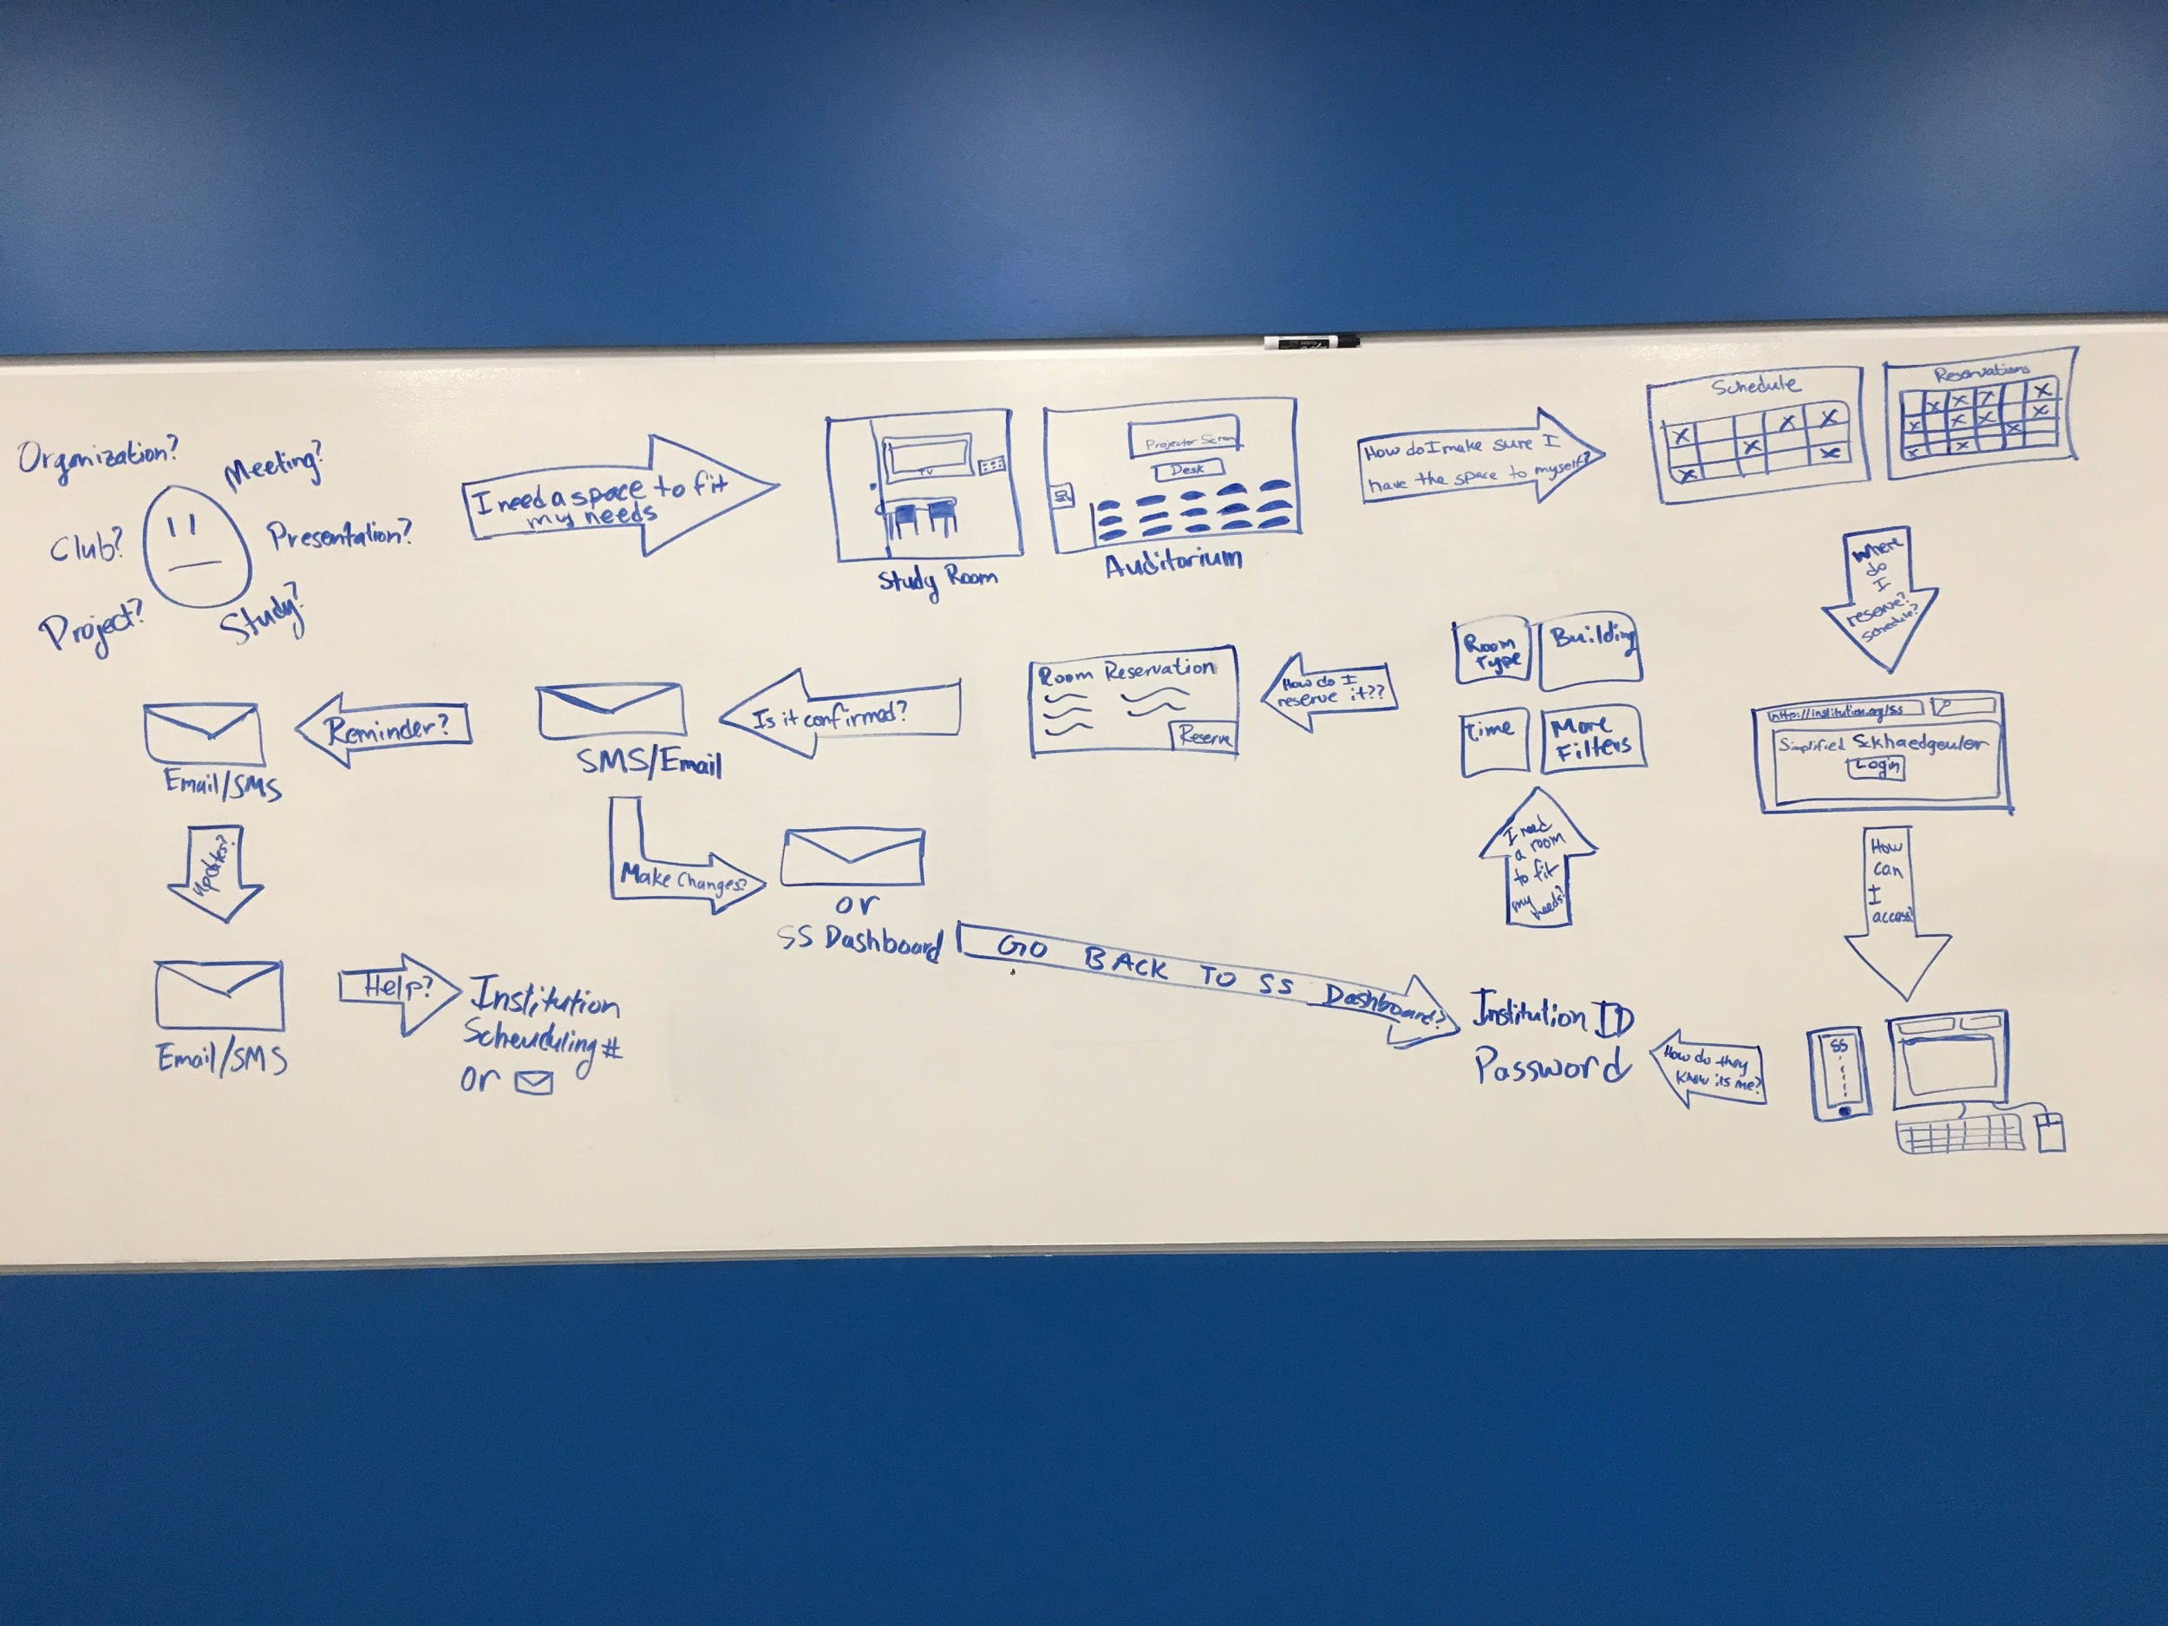

Whiteboard Sketch

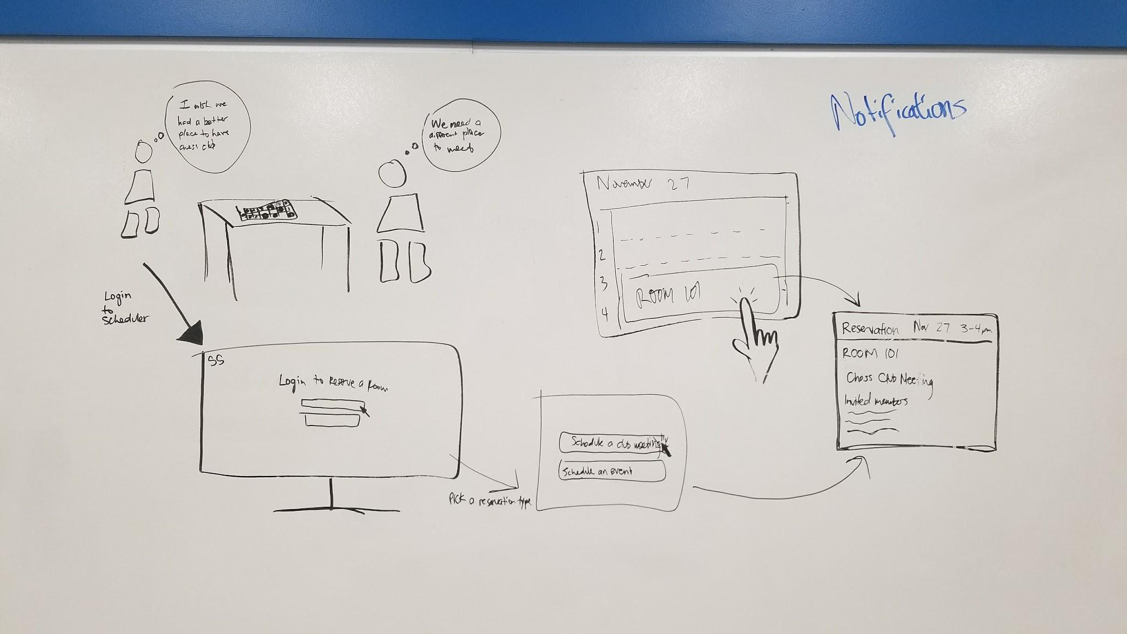

Another Whiteboard Sketch

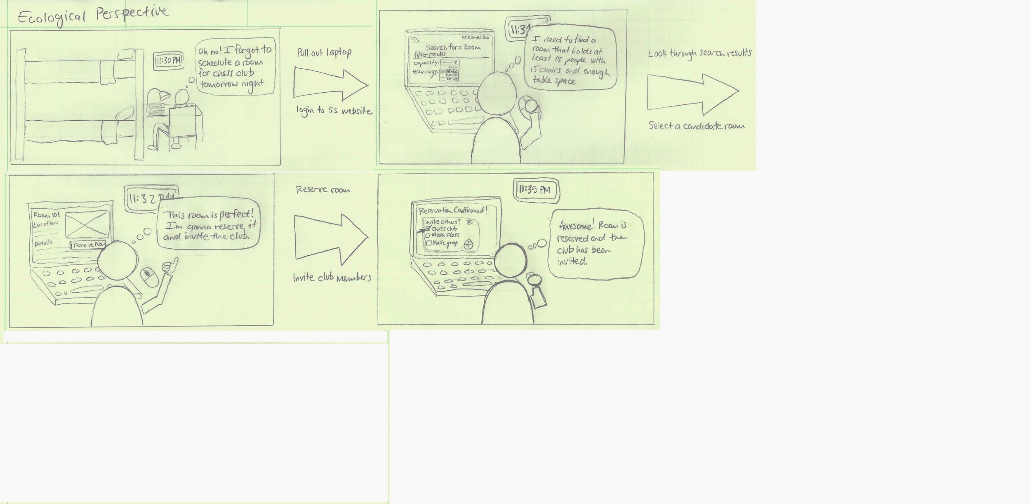

Quick ecological sketch in storyboard style

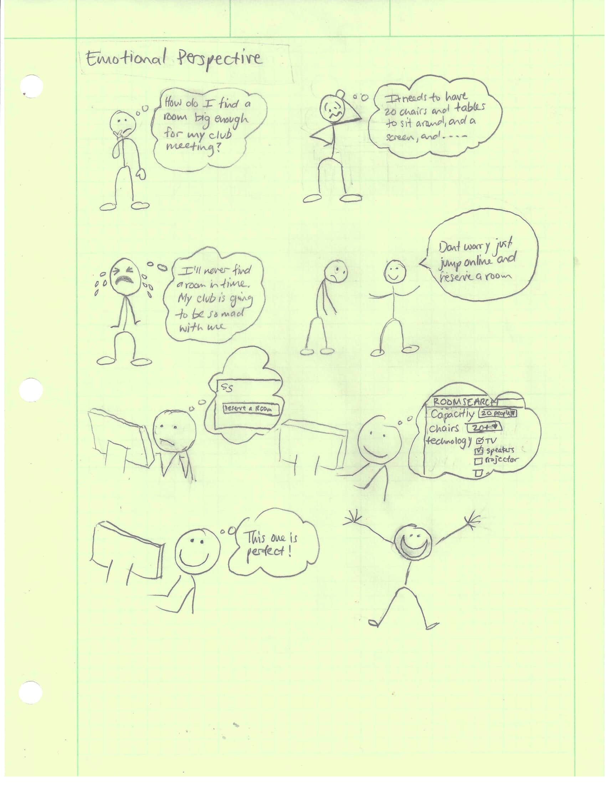

This sketch focused on the emotional perspective during the process of reserving a room.

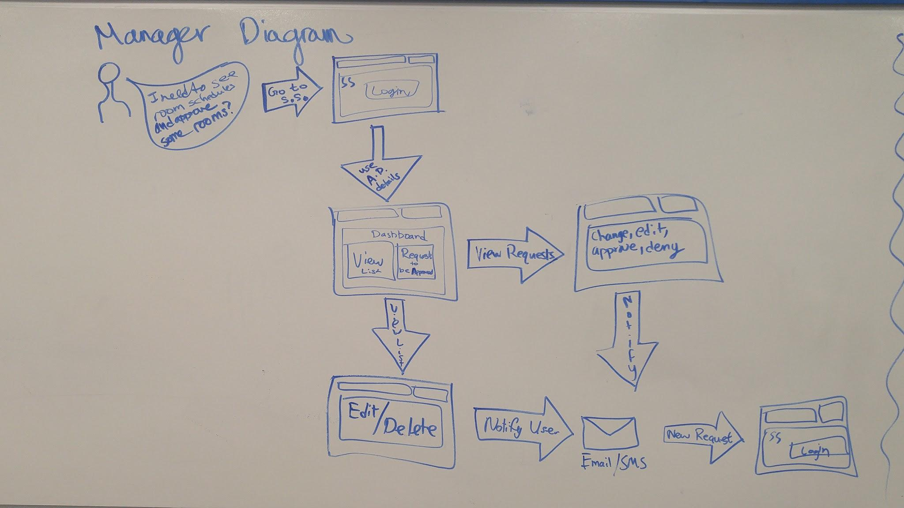

This sketch focused the process a manager would have using *SS* and the communication managers have with normal system users.

# Physical Mockups

We did not create any physical mockups for this phase of the project, it did not seem necessary. We felt we could adequately portray our ideas in other ways as our software is web based we are not designed the devices connecting to the internet.

# Mental Models and Conceptual Design

## Mental Models

We read about a technique that could help us diagram our design mental model and map it to the users mental model. We used our contextual data design-informing models to fill o out this mental model diagram. This technique allowed us to visualize the mental models and fill in any missing gaps.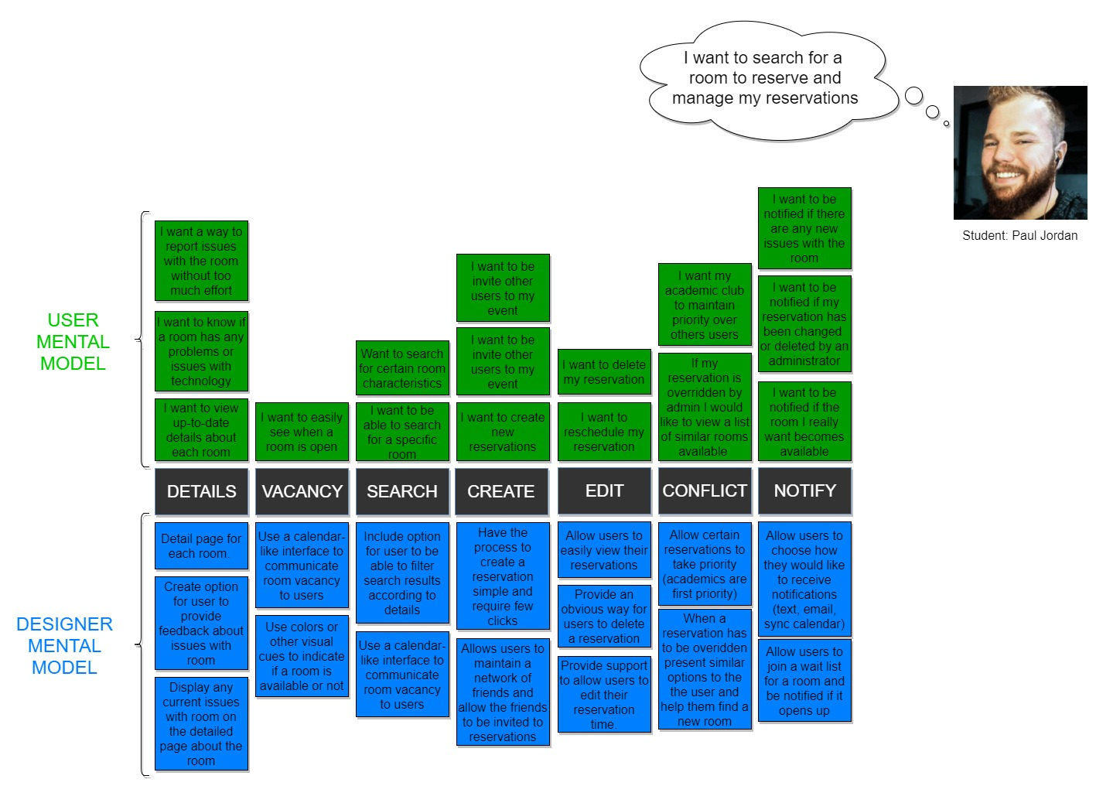

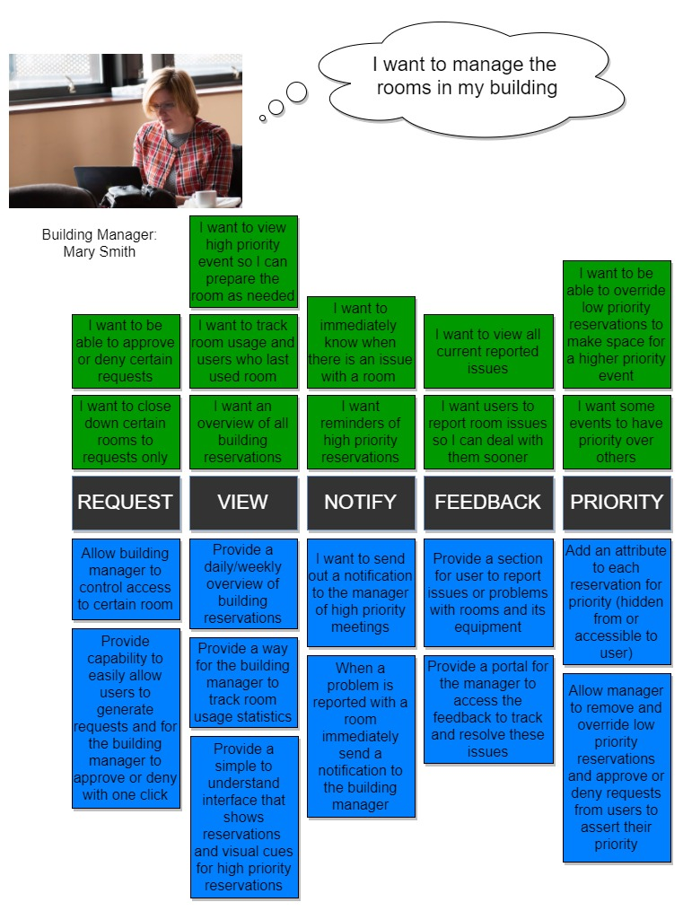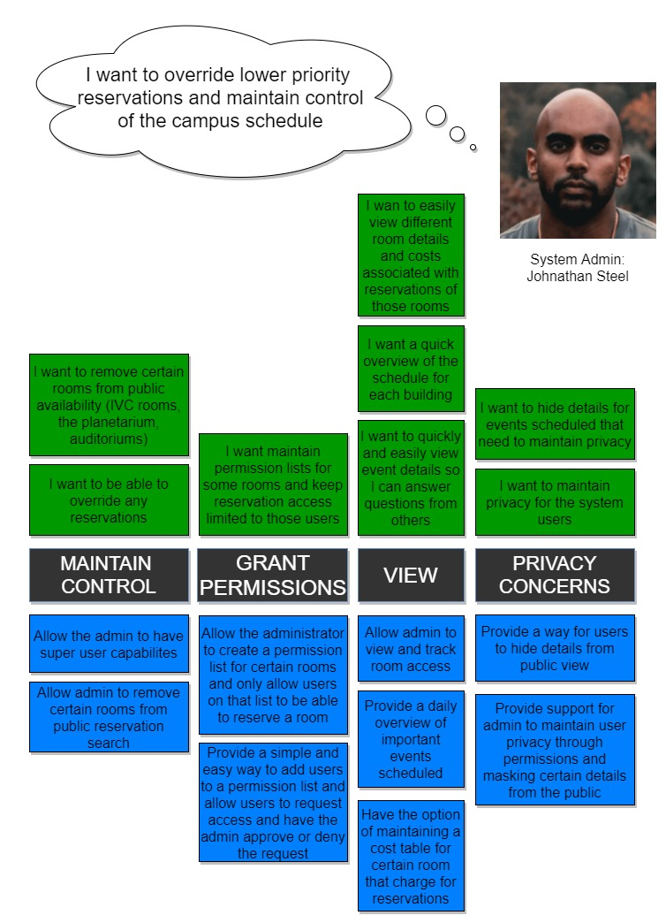

## Conceptual Design

"A mental model is the representation that a person has in his mind about the object he is interacting with. A conceptual model is the actual model that is given to the person through the design and interface of the actual product." (Susan M. Weinschenk. 2011. 100 Things Every Designer Needs to Know About People)

“A designer’s mental model is a vision of how a system works as held by the designer. A user’s mental model is a vision of how a system works as held by the user. It is the job of conceptual design to connect the two.” (Rex Hartson. 2012. The UX Book)

The conceptual design phase in our project acted as a map from our mental model, as designers, to the mental model of our different personas. We took the mental model of each persona and began sketching some conceptual models to match up. During sketching we referred back to design-informing models and our mental model diagram making corrections along the way to ensure they matched up.

## Metaphors Used in Conceptual Design

|  |  |  |  |
| --- | --- | --- | --- |
|  | **Ecological Perspective** | **Interaction Perspective** | **Emotional Perspective** |
| **Student** | The Simplified Sckhaedgeuler is like an easy-to-use filing cabinet with the schedule of each room on campus. | Finding a room is as easy as shopping on Amazon, and creating a reservation is as easy as writing your name on the door. | When you reserve a room with the Simplified Sckhaedeuler, it’s as though you went and inspected the room personally, and wrote your name on the door. You’ll always know exactly what you’re getting. |
| **Manager** | The Simplified Sckhaedeuler is like having an assistant who does all the interacting with students, and tells you only as much as you need to know. | The Simplified Sckhaedgeuler can turn the difficult job of room management, into nothing more than reading a report of what it’s done for you. | Like having your best friend as a co worker, the Simplified Sckhaedeuler will take on a ton of your workload, and keep you in the know. |
| **Administrator** | The Simplified Sckhaedeuler is like a collection of digital calendars, where the administrator can at last have all the control necessary to make sure things run smoothly. | The Simplified Sckhaedeuler is a bird’s eye view of every room on campus, accompanied by the power to change it. | Like a finely tuned machine, the Simplified Sckhaedeuler enables you to do your job well while you’re working, and keep going on it’s own when you’re not. |

## Conceptual Sketches

We created sketches to match with each of the personas. The following pictures are a few of these conceptual sketches we drew. 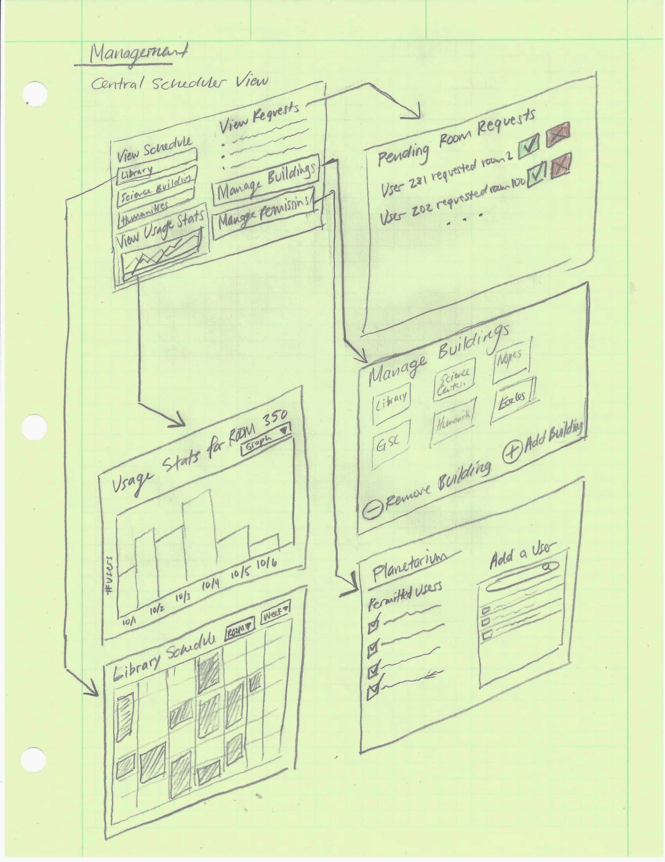

Early conceptual sketch of the managers view.

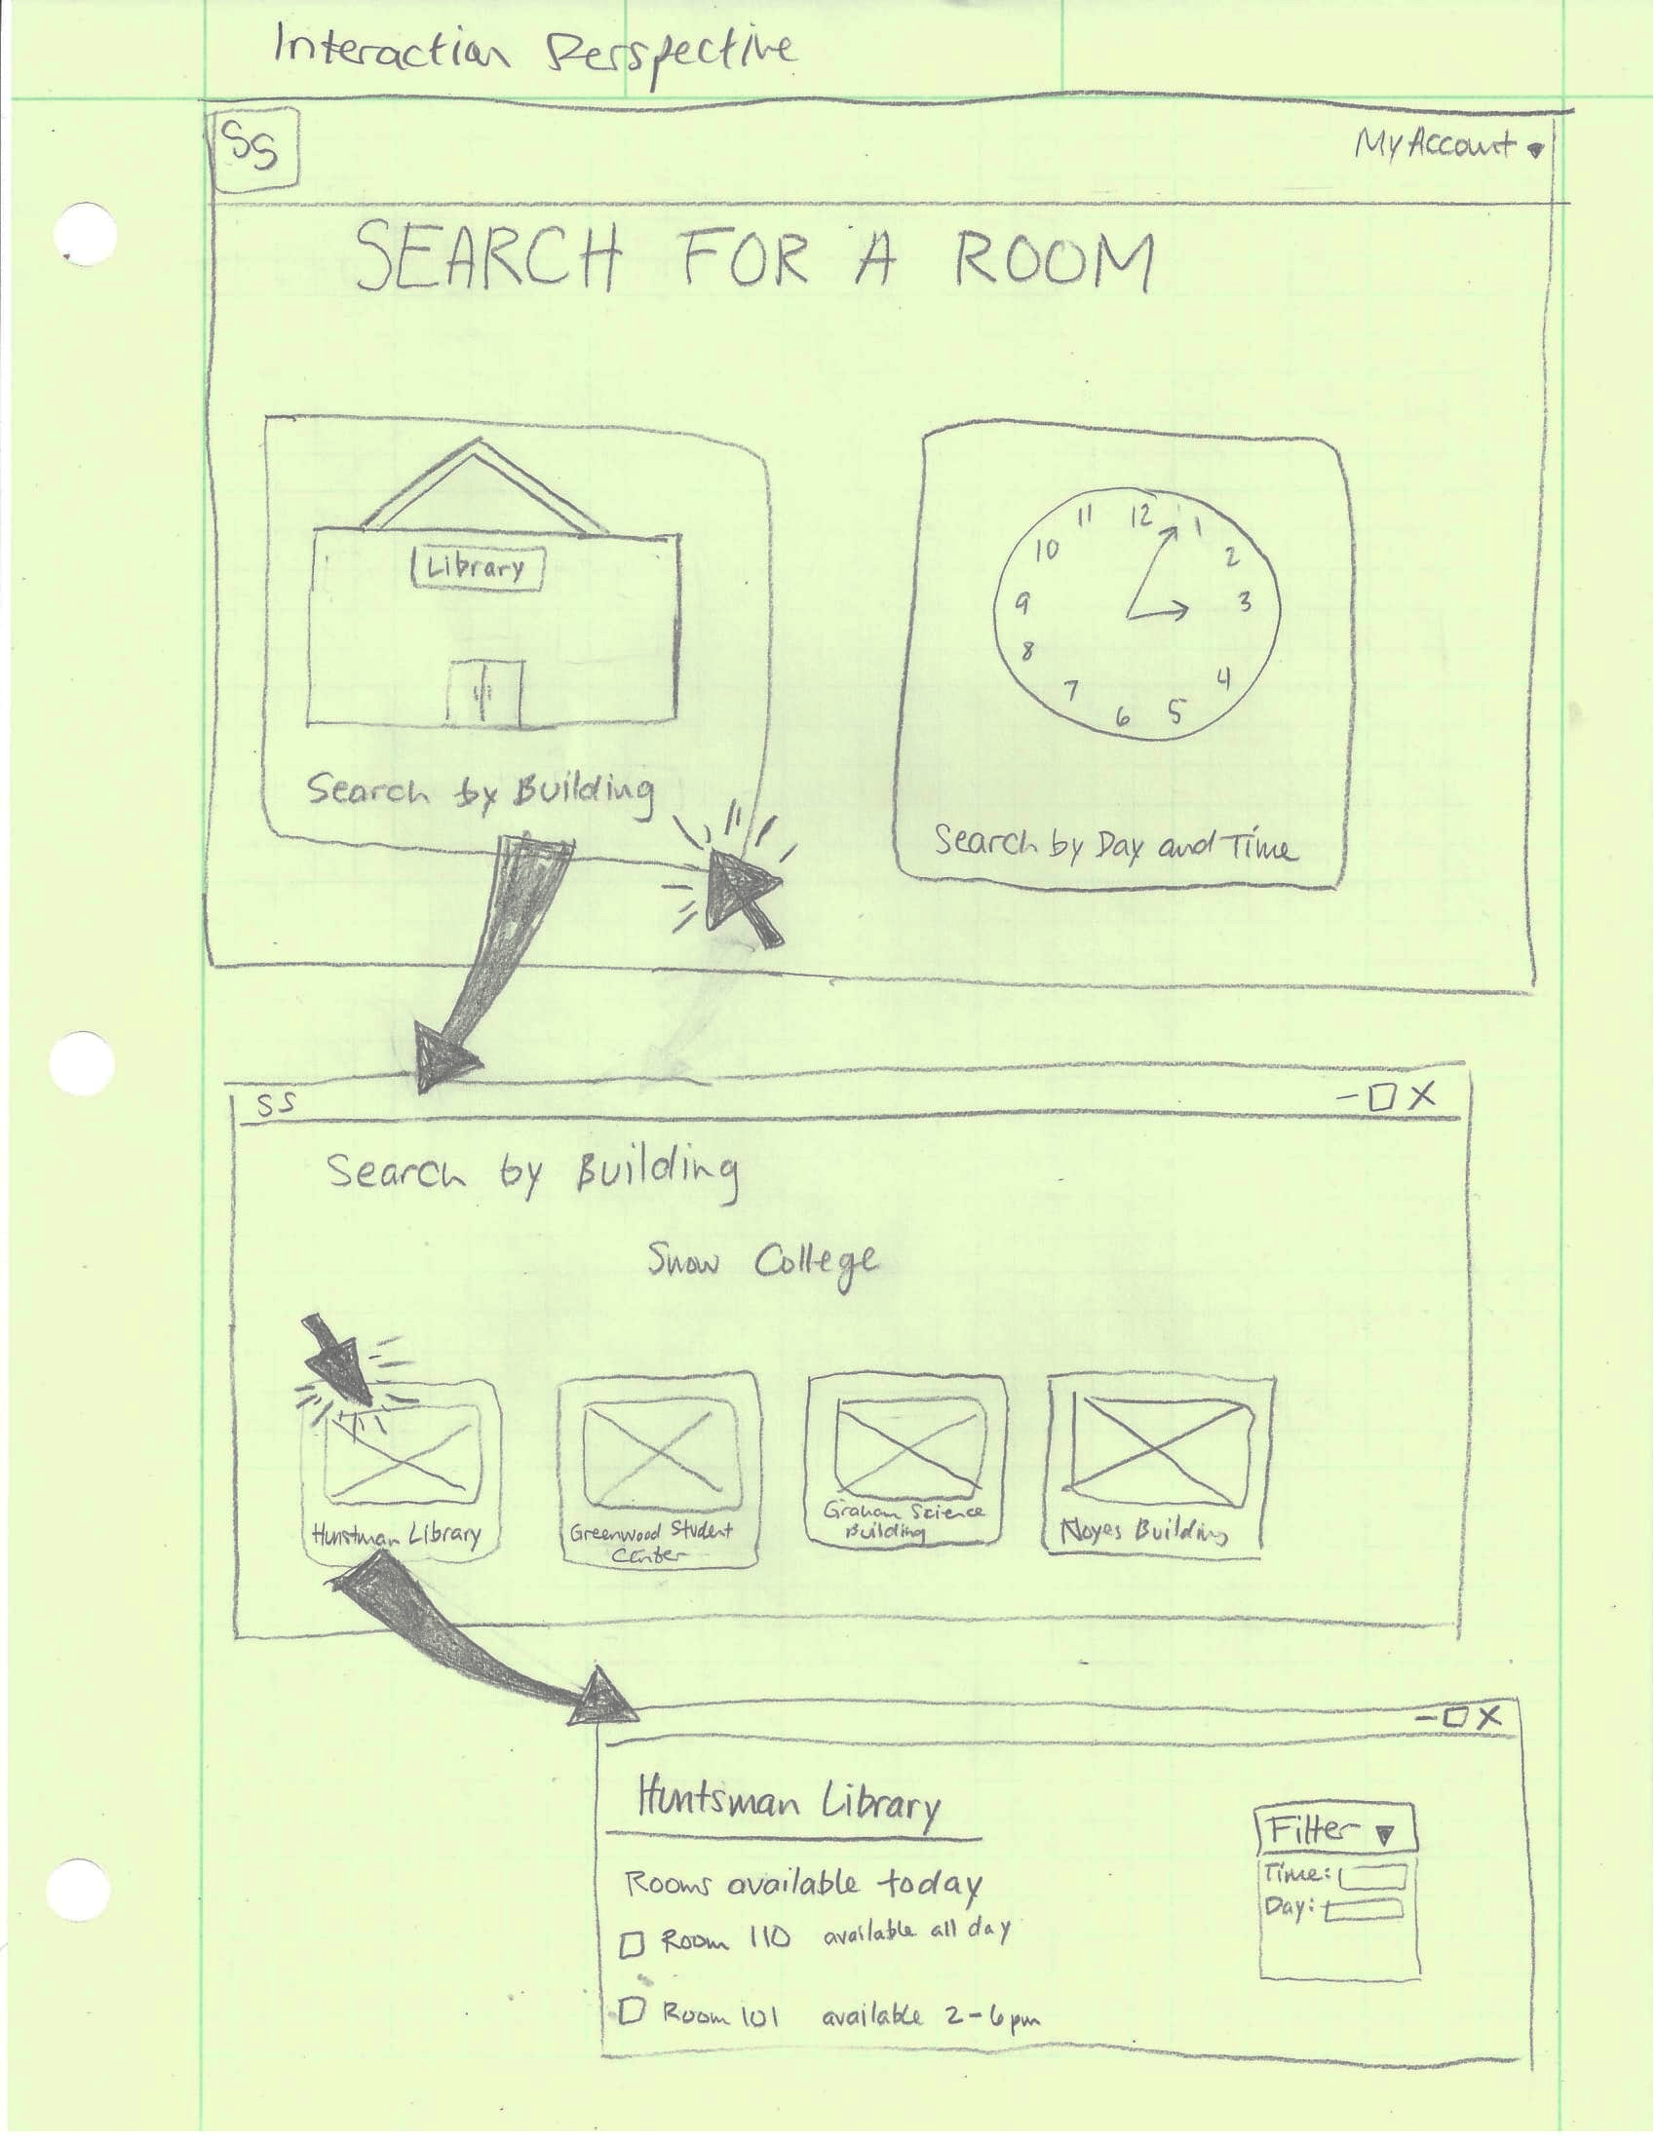

Conceptual sketch focusing on the student perspective.

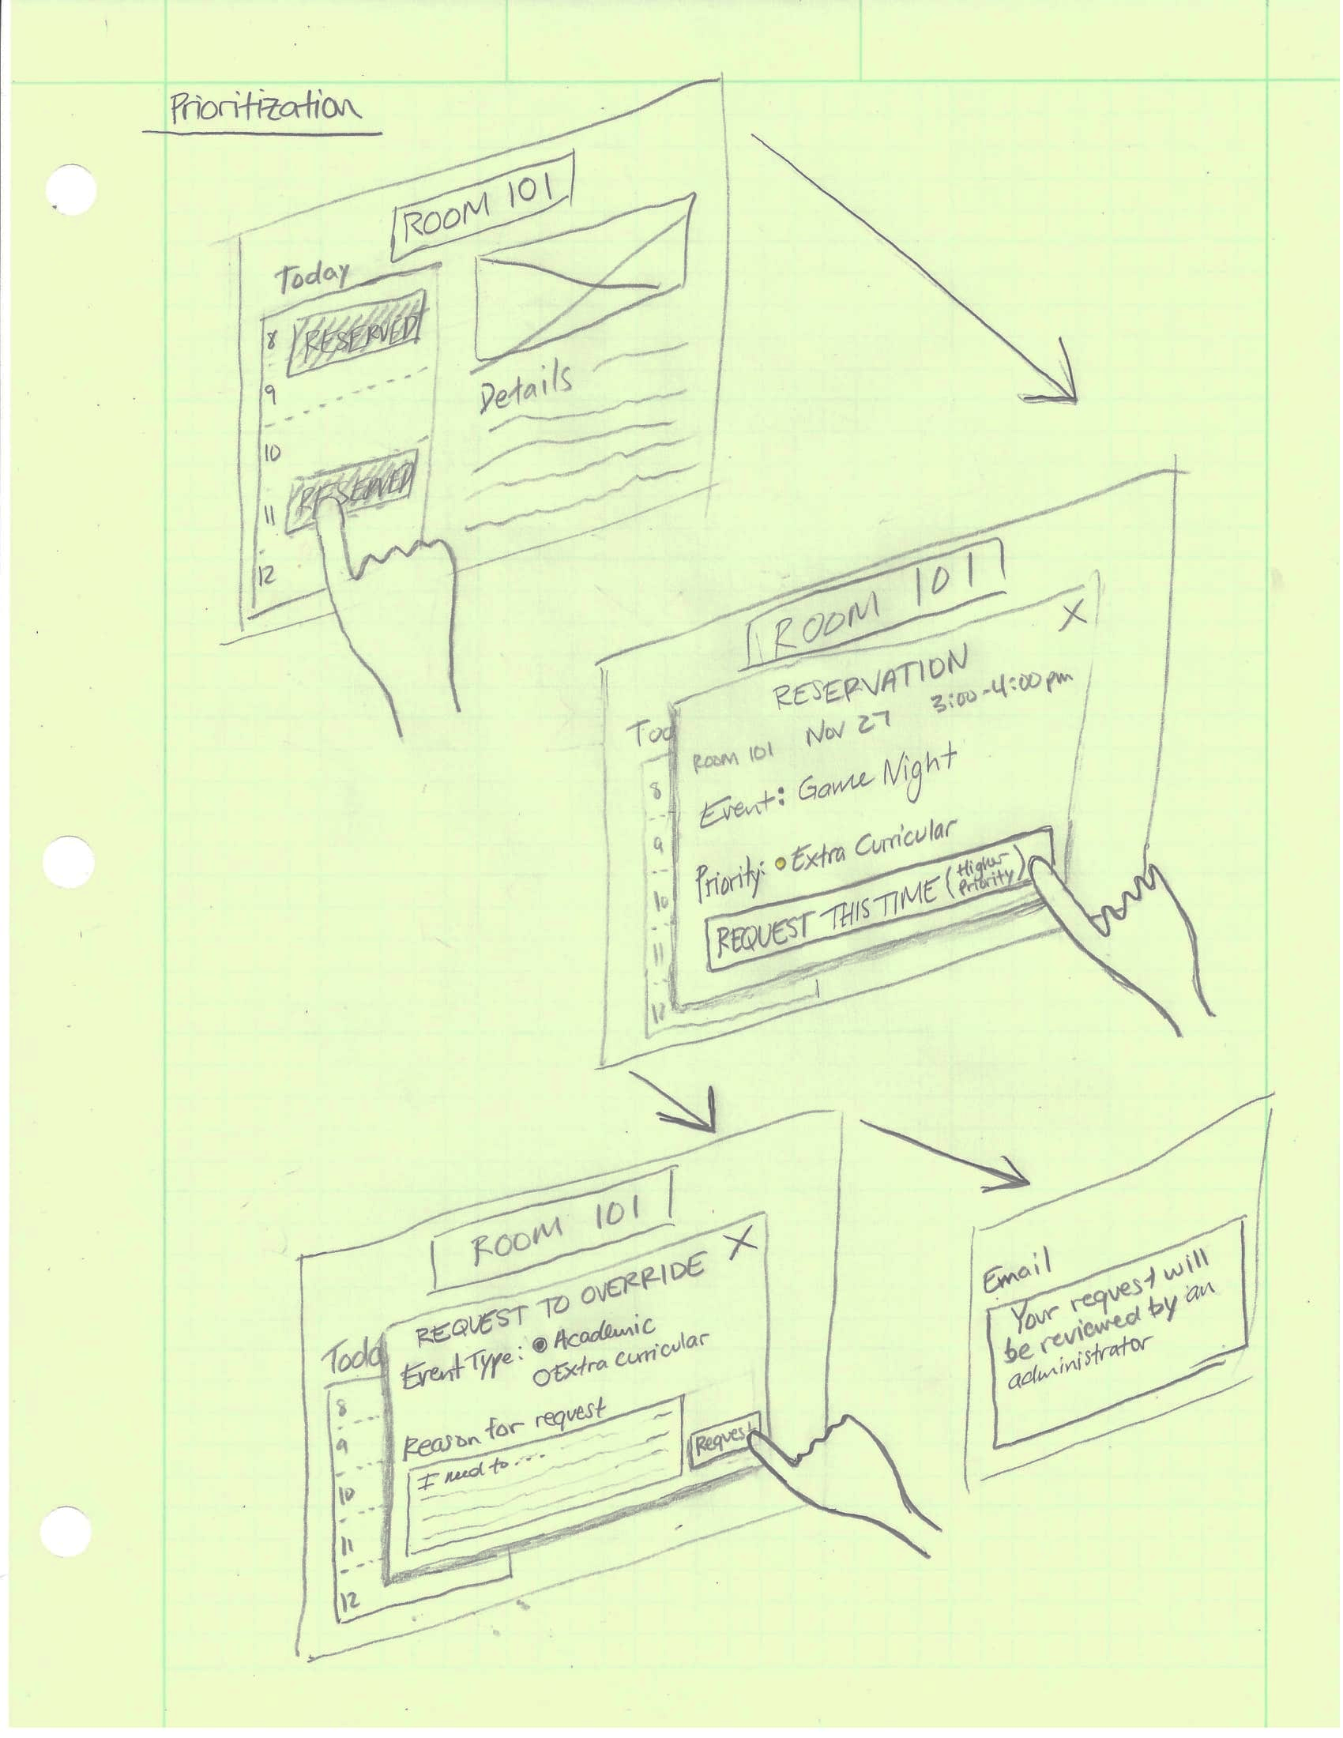

Concept for dealing with reservations of different priorities from the student perspective.

# Storyboards

These storyboards were created for a few different users to help us gain a better understanding of the different perspectives of each respective persona. There is a storyboard for a building manager, student, faculty member, and system administrator. The transition from one frame to another is guided by the thought and speech bubbles. We are able to more fully visualize the user experience through these storyboards.

## 

## Building Manager

This storyboard attempts to depict the frustration a building manager goes through when trying deal with room issues in their building and how our software can solve this problem.

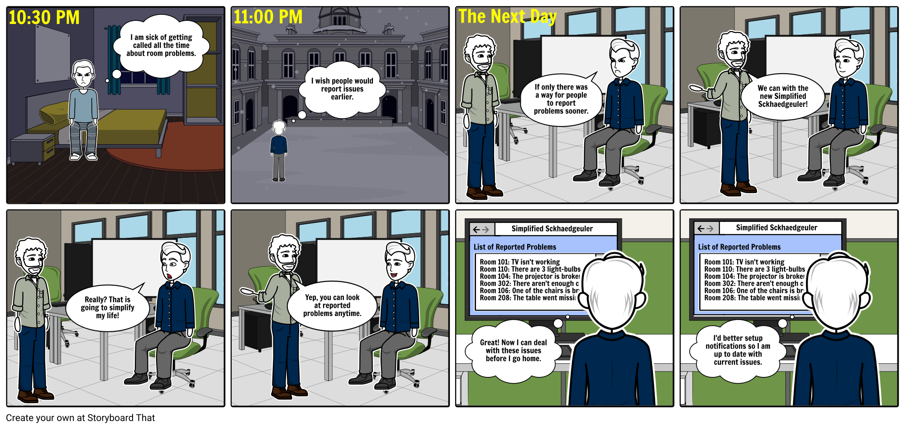

## Student

This storyboard depicts a student's perspective of a need to use the scheduling software to schedule a room for a group project. It is a high level storyboard that show interaction with the envisioned system.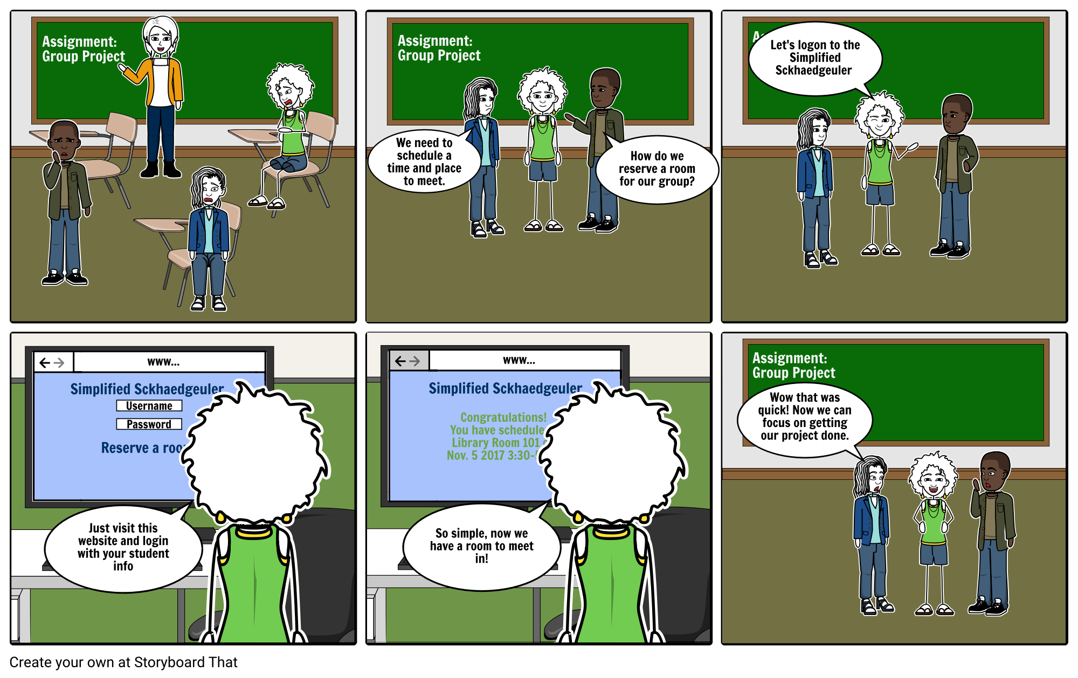

## 

## 

## Faculty

This storyboard contains a depiction of a possible scenario a faculty member might go through to use the envisioned software.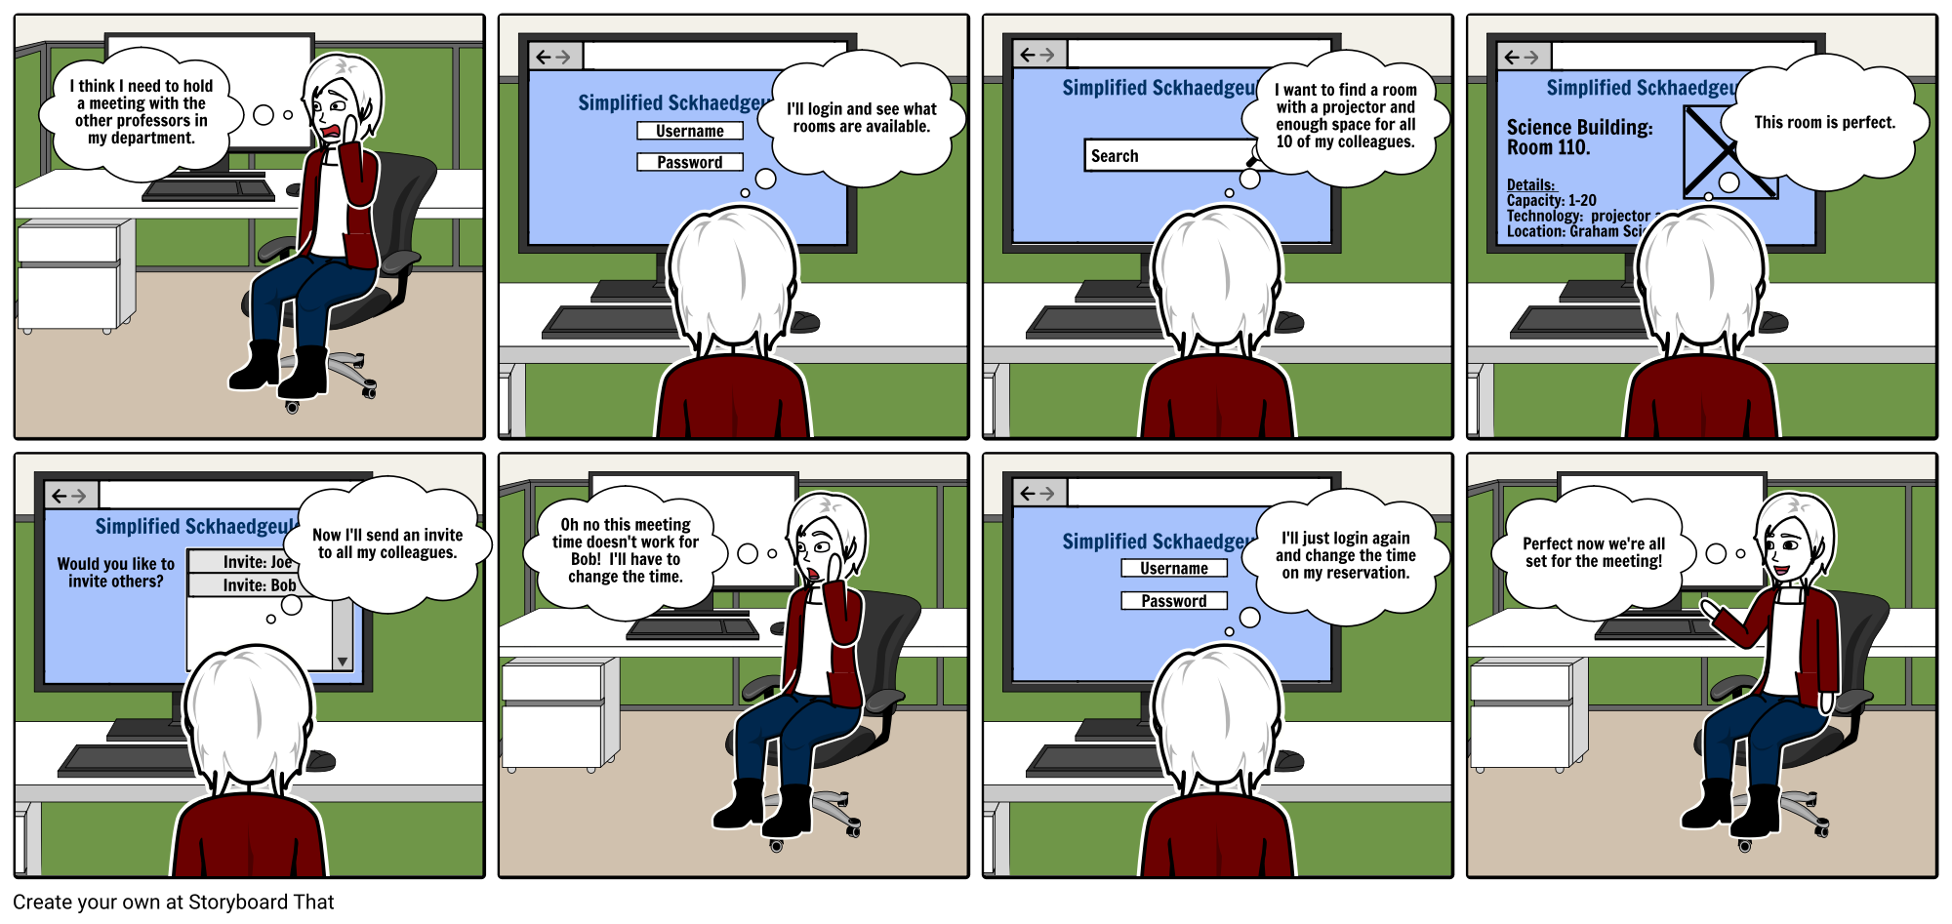

## System Admin

The following storyboard demonstrates some of the features of our system that are only available to the system administrator. It also shown how outside business reservations are handled without specific support for them being built into our product.

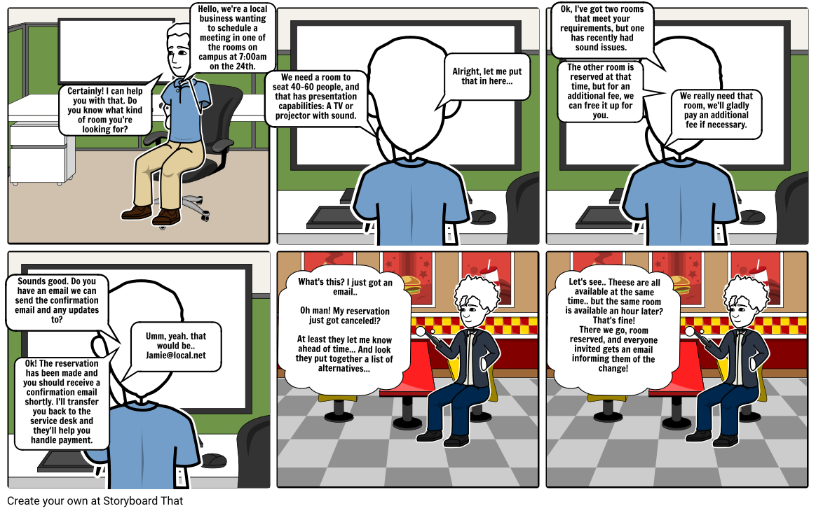

# Wireframes

The wireframes we used were designed principally around the student, and their view as they made a reservation. It was difficult to envision a design that would allow the student to search for a satisfactory reservation based on different constraints, specifically date, room, and time. The following wireframes demonstrate these use cases. The wireframes will be continued to be worked upon on the next project.

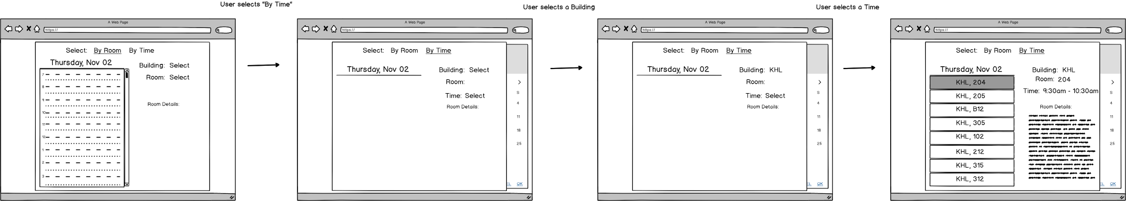

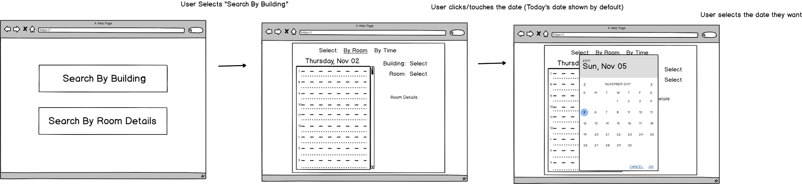

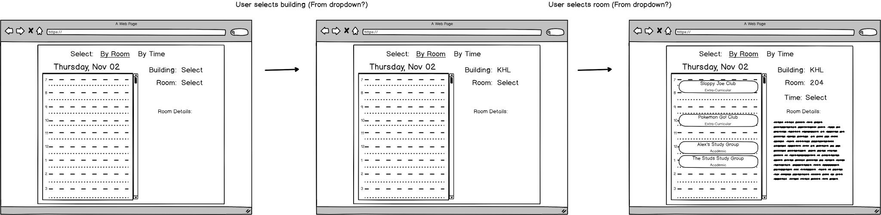

# Our Design Process

## Techniques used

Communication between team members was of extreme importance during this phase. Our main forms of communication were in-person during meetings, comments on our in-progress documents online, virtual meetings and keeping up with each other through text messages. We were in constant communication and met often to work on our design.

We also divided up different parts of the process to work on individually. We assigned things such as sketches and storyboards out to different individuals. We each worked on our own section individually, and then during our meetings we would review each team member's work and make any necessary additions or changes.

Virtual meetings became a necessity during the weekends as we were not always within close enough proximity to meet in person. We used TeamViewer software and collaborated/shared documents and files using G Suite (Google Docs).

In addition to communication, we also used other tools (listed in the appendix) that helped create different types of diagrams within our project. We also used each other; from our experiences as users for so long with software that doesn’t work well and that does, we knew partially of how the users really would feel when coming to use a product like ours.

## Lessons Learned

I think we really began to understand what an undertaking it is to actually design a new product. It requires constant communication between team members and the need to constantly refer back to our contextual analysis to make sure our design matched up with the user's needs. -AT

I learned the importance of designing with the persona in mind. I feel as though many of the features I had originally thought to include were either omitted, or drastically changed as I thought about the needs of a specific persona. When we used the specific design details we extracted from our Work Activity Affinity diagram, that was brilliant.

-LJ

I learned that my ideas are not always the right ideas. How I thought the software should work wasn’t always the best idea. I learned that I might think that I am thinking of the user when I design, however, there are many things that I am forgetting. When working in a team, many more ideas and thoughts can be expressed better I could simply in my own thoughts. I learned that the ideas from the interviews and workshops we did a while ago really do apply to the design that we did in this project.

-JP

## Insights gained

I think we felt like the design phase of this project was a bigger undertaking that we first realized. Our initial tendencies were to jump right over the ideation and sketching and move right into the conceptual design. We had to be extra careful to control this tendency which sometimes required looping back to the beginning and doing more ideation and sketching to make sure we covered all our bases. I think if we were to do this project again we would realize the importance of early ideation and intensely focus our first few meetings around ideation sketching to really bring out more creative ideas and ignore our existing mental models we had at that stage. Looking back to the beginning, our initial mental models from the first activity to now are extremely different and we began to realize the importance of overall process from contextual inquiry up until now.

-AT

The biggest thing I would do differently would be to avoid thinking about the product as a whole at the beginning, and treat each problem separately before combining them into a single product. I would also place a higher importance on thinking about what design decisions will make the product ‘familiar’ to the user, even when they haven’t used it before.

The biggest surprise for me was when we realized that recurring reservations should be approved by the manager. After we realized this it made a lot of sense, and there were a lot of things advocating that approach, but it wasn’t what I had originally envisioned.

-LJ

This project was definitely different for me. It is different that any other project that I have had to do in my previous education. I have seen design and different aspects of doing so in the past, but this project opened my eyes into how design is done in the world today. The biggest surprise for me would probably be the process. Going from ideation and brainstorming, to sketching (which is still hard for me) to wireframes, personas and the conceptual design behind them. Part of this is still confusing to me, but as I get more applications to use this process, I believe I will understand it better.

It was unexpected, unlike other projects, we couldn’t really do this project’s steps in any order that we pleased. It had to be done in a specific order or some parts would not align with each other or would not make sense. If I was able to do this project again, I would schedule a long session to be with my group where we do *all* the steps together so we can get better input from each other on what the software should look, feel and give to the users.

-JP

# 

# 

# Appendix

## Reading

Hartson, R., & Pyla, P. S. (2016). *The UX book: process and guidelines for ensuring a quality user experience*. Amsterdam: Morgan Kaufmann.

The Secret to Designing an Intuitive UX. (n.d.). Retrieved November 01, 2017, from <https://uxmag.com/articles/the-secret-to-designing-an-intuitive-user-experience>

Christina Wodtke, Curious Human Follow. (2013, November 04). Conceptual models & Mental Models. Retrieved November 01, 2017, from <https://www.slideshare.net/cwodtke/conceptual-models-mental-models>

Visual Thinking. (n.d.). Retrieved November 04, 2017, from http://www.xplaner.com/visual-thinking-school/

## Resources

* Computer Science Classroom (Whiteboards, markers, computers)
* Paper and Pencil for sketches
* Google
* G Suite (For online collaboration)
* Balsamiq (Wireframe Software)
* <http://draw.io> (Diagramming Software)
* Storyboard That (Storyboarding software)
* Mobility Labs (Persona Template Generator)
* TeamViewer (To hold virtual meetings)